Predicting National IQ Scores with Linear Mixed Models

Austin Brewer

Intelligence Quotient (IQ) is the most popular tool for measuring intelligence in the world. The importance of intelligence is very widespread; from determining whether one can make the next great scientific breakthrough to whether one can build a shelter or find food for survival. Given the importance of individual intelligence, one can extrapolate that intelligence spread across an entire nation would be extremely valuable. For this project, I am going to build a model in order to predict the average intelligence for countries given a combination of predictors. This model could provide interesting insight to which factors are important in determining a nation’s intelligence.

The data consists of 10 variables, which include country name, continent, IQ, IQ ranking, literacy rate, number of total Nobel prizes, HDI, GNI, mean years of schooling, and population. GNI refers to gross national income, which is the total income for a nation across all businesses and individuals. The GNI in our data is on a per-capita basis. HDI refers to human development index, which is a composite measurement of mean years of schooling, expected years of schooling, life expectancy, and national income. HDI overlaps with some of the other variables in the dataset, so it will be investigated for collinearity. Some data was eliminated due to missing values. I deemed this move to be acceptable, as most of the countries eliminated are considered territories or are small countries to begin with. 14 were removed in total, with some of the most prominent being North Korea, Taiwan, Puerto Rico, and the British Virgin Islands.

The model that I ultimately selected was a mixed model featuring GNI, population, and mean years of schooling as fixed effects and continent as a random effect. This first step of this process was to test for collinearity between predictors. As previously mentioned, HDI was assumed to be a culprit of this as it is partially a function of other predictors in this dataset. HDI and GNI had a correlation measure of 0.79, which is certainly a concern but isn’t enough to completely drop during the model building process. A correlation measure of 0.91 between HDI and mean years of schooling, however, was determined to be enough for removal when also in combination with the previously determined correlation. Below are two basic plots demonstrating the collinearity.

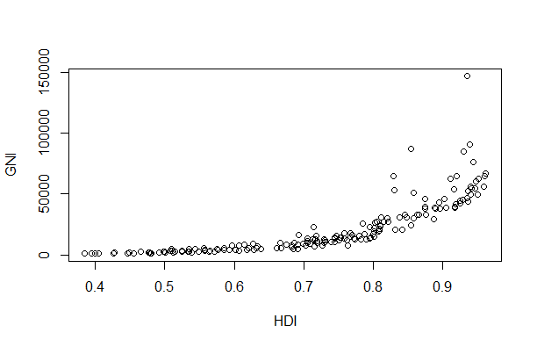

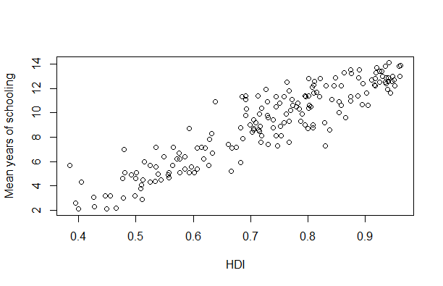

The final area of potential collinearity that caught my attention was between GNI and mean years of schooling. With a correlation of 0.66, it is by no means overly concerning, but it is worth noting as both of those variables were selected in the final model. The next step in the model process was determining correlation between the response and potential predictor variables. In testing, the only predictors with correlations below 0.63 were population and Nobel prizes. This is very interesting as population held a 0.07 correlation measure with average IQ, yet it managed to survive the selection process. The selection process I used was a series of Kenward-Rogers F-tests with adjusted degrees of freedom. The noteworthy test in this process is that of population. The p-value in determining whether population would be a significant contribution to the model was 0.057. If using a standard significance level of 0.05, population would just come short. With it coming this close, I decided to leave it in the model and keep the desired significance level at 0.1.

The random effect, continent, was also confirmed to be a significant addition to the model. Before testing the model, I performed a one-way anova test between average IQ and continent to get an idea of whether there was even a significant difference in the average IQ between the continents to begin with. The test confirmed this, as I suspected it would. There are many differences among the continents, with their geography being a major factor. For example, a North American country with at least two sea borders (ideal for trade and defense), excellent climate for agriculture, and an abundance of natural resources, will likely have great advantages over a land-locked, African nation with an arid climate and minimal natural resources. Furthermore, these innate differences could lead a country with identical GNI, schooling, and population to a different average IQ. While it might not fit the traditional use of random effects (I’m not sampling out of a large population of continents, I am only leaving out Antarctica), I still determined it would still be appropriate as continent isn’t a focus of our modelling/analysis but it still captures plenty of variance due to some of the reasons previously mentioned. The continents may also be viewed as “bins” for their respective comprising countries, and there is variance captured between these bins that is not a focus yet is still important.

It is also worth noting the interpretation of the model’s coefficients. For a 1-year increase in the mean years of schooling, a nation’s average IQ increases by 1.39 points. For a 1 dollar increase in GNI per-capita, average IQ increases by 0.00134 points. For a 1 person increase in total population, average IQ increases by 0.0000000077 points (very small number, but it makes sense when populations can be in the billions). The values for each of the random effect levels are as follows; Africa=-7.14, Asia=1.06, Central America=-6.91, Western Europe=4.55, Eastern Europe=1.16, North America=1.86, Oceania=4.69, South America=0.72. Since these coefficients are intercept points for individual lines of a fixed slope, they can be ordered by the value of the intercept if trying to determine which continent has the greatest impact on IQ (Oceania has the greatest positive impact and Africa has the greatest negative impact).

After the completion of the modelling process, diagnostic checks were performed. The following plots were used to determine normality in the residuals and heteroskedasticity in the errors. The first plot is a fitted vs residual plot:

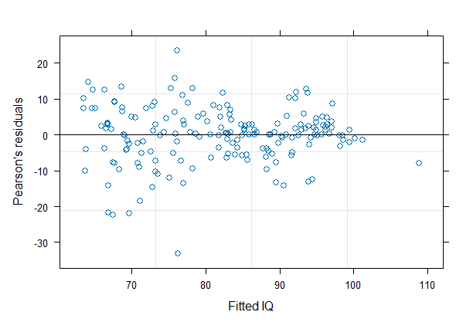

This plot, if anything, may show a slight decrease in the errors as the fitted values increase. It is by no means egregious, but out of curiosity, I tested a log transformation on the response to see whether a quick fix could be made. After the plot post-transformation only increased the variance of the errors at lower fitted values, I decided to accept the model as it currently is. The next plot is a qq-plot:

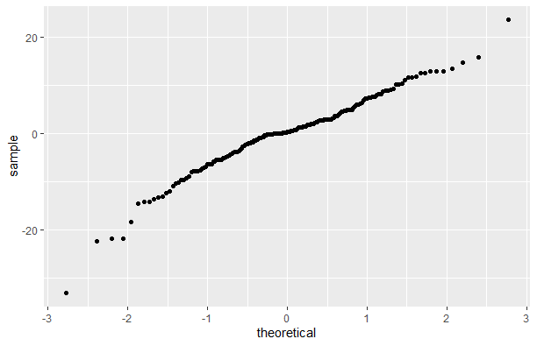

The plot appears to show generally show normality in the residuals as desired.

The final portion of this project was directed at predicting average IQs of the past. More specifically, average IQ scores for the United States every 5 years from 1965-2020. After collecting the required data from various sources and feeding it into the model, the results show a relatively steady increase in average IQ since 1965.

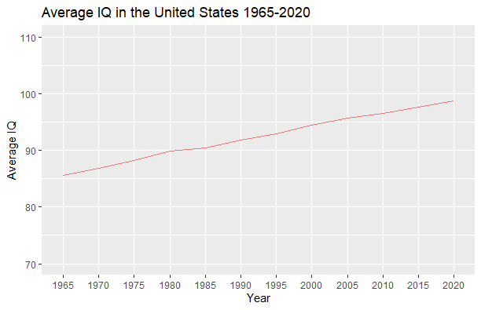

Every decade in the predictions experienced a 2-4 point increase in IQ over the 55 year time span. This kind of increase is backed by research too. James Flynn, a world-renowned intelligence researcher from New Zealand, concluded from his work that IQ scores rise 3-5 points on average every decade. In a country like the U.S., that has been at the forefront of sectors such as health, nutrition and education for a long time, it will be more challenging to sustain continuously high jumps in IQ. This may prove to make these results even more accurate, as the countries driving up Flynn’s estimate may be those like China, which realize massive improvements in key sectors in a very short amount of time. An interesting extension of this analysis would be to estimate the average IQ of the world, and then compare that with current measurements. Doing so would require an adjustment to the model, as population may need to be altered or removed altogether. With population maintaining a positive correlation with IQ and lacking any easy adjustments (like converting GNI to GNI per-capita), the estimate may become over-inflated. Regardless, this model lays the framework for what could be interesting analysis in predicting past, present, and future IQ scores for entire nations, or even the whole world.